COVER PAGE

Finance for Non-Finance Managers

Learner’s Guide

Version Control Record

Version | Effective Date | Changes | Author
1.0 | 01/06/2022 | - | Tertiary Infotech Pte Ltd

Copyright 2022, Tertiary Infotech Pte Ltd. All rights reserved.

This document is provided for the explicit use and guidance of learners of Finance for Non-Finance Managers program with Tertiary Infotech Pte. Ltd. Any other use of this document or parts thereof, including reproduction, publication, distribution, transmission, re-transmission or public showing, or storage in a retrieval system in any form, electronic or otherwise, for purposes other than that expressly stated above without the express permission of Tertiary Infotech Pte Ltd. is strictly prohibited.

For enquiries and feedback about this competency unit, please email info@tertiaryinfotech.com
Content

Contents
Lesson 1: Financial statements and Ratio Analysis 7
1. What are Financial Statements? 8
2. Users of financial statements 8
3. Key financial statements 9
4. Balance Sheet 9
5. Balance sheet components 9
6. Assets 10
1. Current Assets – Cash and Cash Equivalents 10
2. Current Assets – Accounts Receivable 11
3. Current Assets – Inventory 11
4. Current Assets – Marketable Securities 12
7. Long Term Assets – Plant Property and Equipment 12
1. Valuation of PP&E 13
2. Depreciation of PP&E 13
3. Common Depreciation Methods 14
4. Depreciation – Straight Line Method 14
5. Depreciation – Double Declining Method 15
6. Depreciation – Units of Production Method 16
7. Depreciation – Sum of Years Method 17
8. Long Term Assets – Intangible Assets 18
9. Liabilities 19
10. Current Liabilities – Accounts Payable 19
1. Current Liabilities – Current Debt 19
2. Current Liabilities – Current Portion of Long Term Debt 20
3. Long Term Liabilities – Bonds Payable 20
4. Long Term Liabilities – Long Term Debt 21
5. Working Capital 22
11. Shareholder’s Equity 22
1. Shareholder’s Equity – Share capital 22
2. Shareholders Equity – Retained Earnings 23
3. Balance Sheet of Starhub 24
12. Summary of different Balance Sheet Items 24
13. Classification of items 24
14. Income Statement 25
15. Income Statement components 25
16. Sample Income Statement 27
17. Earnings Per Share 28
18. Accrual vs Cash Accounting 29
19. Expense Recognition 30
20. Revenue Recognition 31
21. Cash Flow Statement 32
1. Cashflow statement – Operating Activities 32
2. Cashflow statement – Investing Activities 32
3. Cashflow statement – Financing Activities 33
22. Statement of changes in equity 34
1. Statement of changes in equity - components 35
23. Summary of Income Statement Items 36
24. Summary of Cashflow items 36
25. Proforma Financial Statements (Projection) 36
26. Projection of Income Statement 37
27. Forecasting of Balance Sheet 37
28. Forecasting of Cash Flow Statement 38
29. Cash Flow forecasting methods 39
30. Financial Ratios 39
1. Liquidity Ratios 40
2. Liquidity Ratios – Current ratio 40
3. Liquidity Ratios – Acid Test Ratio 40
4. Liquidity Ratios – Cash Ratio 40
5. Liquidity Ratios – Operating Cash Flow Ratio 40
31. Leverage Financial Ratios 40
1. Leverage Ratio – Debt Ratio 41
2. Leverage Ratio – Debt to Equity Ratio 41
3. Leverage Ratio – Interest Coverage Ratio 41
4. Leverage Ratio – Debt Service Coverage Ratio 41
32. Efficiency Ratios 41
1. Efficiency Ratios – Asset Turnover Ratio 41
2. Efficiency Ratio – Inventory Turnover Ratio 41
3. Efficiency Ratio – Accounts Receivable Turnover Ratio 42
4. Average Collection Period 42
5. Importance of Average Collection Period 42
6. Average Collection Period - Illustration 43
7. Efficiency Ratio – Accounts Payable Turnover Ratio 43
8. Average Payments Period 43
9. Average Payments Period – Illustration 44
33. Profitability Ratios 44
34. Profit Margins – Gross Margin 44
35. Profit Margins – Operating Margin 45
36. Profit Margins – Net Profit Margin 45
37. Profit Margins – Return on Assets 45
38. Profit Margins – Return on Equity 45
39. Illustrations of calculations of financial ratios 45
40. Financial Ratios in Banking 47
Lesson 2: Financial Performance Analysis and Capital Budgeting 50
41. Financial Statements Analysis 50
42. Financial Statements Analysis - methods 50
43. Ratio Analysis 51
44. Ratio Analysis – Example 51
1. Current Ratio 53
2. Quick Ratio 54
3. Operating Profitability 54
4. Overall Profitability 55
5. Return on Equity 55
6. Return on Capital Employed 55
7. Inventory Turnover Ratio 56
8. Receivables Turnover Ratio 56
9. Payables Turnover Ratio 57
10. The Debt to Equity Ratio 57
11. Financial Leverage 58
45. Horizontal Analysis 58
46. Vertical Analysis 59
47. Horizontal Analysis – Case Study 60
48. Benchmarking of Financial Performance 65
49. Capital Budgeting 66
50. Time value of Money 66
51. Capital Budgeting Process 67
52. Capital Budgeting Methods 67
53. Payback Period 67
54. Payback Period Example 68
55. Discounted Payback Period 68
56. Discounted Payback Period - Example 69
57. Net Present Value 69
58. Net Present Value Example 70
59. Profitability Index 71
60. Profitability Index – Example 72
61. Internal Rate of Return 73
62. Internal Rate of Return – Example 73
63. Financial Ratios for a sample company 73

Lesson 1: Financial statements and Ratio Analysis

Learning Objectives:
By the end of this session, learners will be able to
- Review the financial statements such as balance sheet, income, and cash flow statements from a financial performance perspective.
- Assess the profitability of the organization using statement of financial position and balance sheet.

What are Financial Statements?
An organization has a lot of information about its operations such as what is income, where is money being spent, what is marketing spending etc. These are usually known to the management and staff.
Financial statements are a way of summarising this information and presenting to the public or outsiders.
Financial statements are a collection of summary-level reports about an organization's financial results, financial position, and cash flows.

Users of financial statements

Company Management
The management team needs to understand the profitability, liquidity, and cash flows of the organization every month, so that it can make operational and financing decisions about the business.
Competitors
Entities competing against a business will attempt to gain access to its financial statements, in order to evaluate its financial condition. The knowledge they gain could alter their competitive strategies.
Customers
When a customer is considering which supplier to select for a major contract, it wants to review their financial statements first, in order to judge the financial ability of a supplier to remain in business long enough to provide the goods or services mandated in the contract.
Employees
A company may elect to provide its financial statements to employees, along with a detailed explanation of what the documents contain. This can be used to increase the level of employee involvement in and understanding of the business.
Governments
A government in whose jurisdiction a company is located will request financial statements in order to determine whether the business paid the appropriate amount of taxes.
Investment Analysts
Outside analysts want to see financial statements in order to decide whether they should recommend the company's securities to their clients.
Investors
Investors will likely require financial statements to be provided, since they are the owners of the business and want to understand the performance of their investment.
Lenders
An entity loaning money to an organization will require financial statements in order to estimate the ability of the borrower to pay back all loaned funds and related interest charges.
Rating Agencies
A credit rating agency will need to review the financial statements in order to give a credit rating to the company as a whole or to its securities.
Suppliers
Suppliers will require financial statements in order to decide whether it is safe to extend credit to a company.
Unions
A union needs the financial statements in order to evaluate the ability of a business to pay compensation and benefits to the union members that it represents.

Key financial statements

These are the three statements for each of the 3 goals discussed earlier
The balance sheet displays the financial position of the company
The income statement (profit and loss statement) shows the financial results of the company
The cash flow statement breaks down all the cash inflows and outflows of the company

Balance Sheet

The balance sheet displays the company’s total assets and how the assets are financed, either through either debt or equity.
It can also be referred to as a statement of net worth or a statement of financial position.
The balance sheet is based on the fundamental equation: Assets = Liabilities + Equity.

Balance sheet components

Assets
An asset is an item that the company owns, with the expectation that it will yield future financial benefits.
This benefit may be achieved through enhanced purchasing power (because it has reduced the expenses of the company, for example a technology solution),
revenue generation (such as factory that produces cars that the company would sell)
or cash receipts (the cash or other financial assets available in the company).

Current Assets
Current assets represent the value of assets that are either cash or can be converted into cash to pay for short-term financial operations and fund operational expenses. These assets that are typically used within a year.
Long Term assets (or non-current assets)
Noncurrent assets, on the other hand, are long-term assets and investments by a business that cannot be liquidated easily. This includes both fixed assets as well as intangible assets. Used in the operation of the company and offer benefits beyond a year

Liabilities
Amounts that are owed by the company and they have to pay in the future

Current Liabilities
Those amounts or loans that are expected to be settled within one year
Long Term Liabilities (or non-current liabilities)
Those loans that are ongoing and expected to be settled in the future (beyond one year)

Equity
This is comprised of the original money that was used to start the business and the accumulated surplus from operations that has not been withdrawn by the owners.

Assets

Current Assets – Cash and Cash Equivalents
Cash and Equivalents
The most liquid of all assets, cash, appears on the first line of the balance sheet.
Cash Equivalents are also lumped under this line item and include assets that have short-term maturities under three months or assets that the company can liquidate on short notice, such as marketable securities. Companies will generally disclose what equivalents it includes in the footnotes to the balance sheet.
Financial Assets can be classified as current assets or long term assets depending on when they will be available.

Cash includes legal tender, bills, coins, checks received but not deposited, and checking and savings accounts. Cash equivalents are any short-term investment securities with maturity periods of 90 days or less. They include bank certificates of deposit, banker’s acceptances, Treasury bills, commercial paper, and other money market instruments.

Cash and its equivalents differ from other current assets like marketable securities and accounts receivable, based on their nature. However, certain marketable securities may classify as a cash equivalent, depending on the accounting policy of a company.
The full list of cash equivalents includes the following items with maturity dates that are typically three months or less:
Banker’s acceptance
Commercial paper
Treasury bills
Other liquid investments that mature within three months
Companies may elect to classify some types of their marketable securities as cash equivalents. This depends on the liquidity of the investment and what the company intends to do with such products. Typically, this will be disclosed in the footnotes of a company’s financial statements.

Current Assets – Accounts Receivable
Accounts Receivable
This account includes the balance of all sales revenue that is still due from the customers. As companies recover accounts receivables, this account decreases, and cash increases by the same amount.

Accounts receivable are the funds that customers owe your company for products or services that have been invoiced. The total value of all accounts receivable is listed on the balance sheet as current assets and include invoices that clients owe for items or work performed for them on credit.
Generally, vendors bill their customers after providing services or products according to terms mutually agreed on when a contract is signed, or a purchase order is issued. Terms typically range from net 30 — that is, customers agree to pay invoices within 30 days — to net 60 or even net 90, which a company may choose to accept to secure a contract. However, for large orders, a company may ask for a deposit up front, especially if the product is made to order. Services firms also frequently bill some portion of their fees up front.
Once a company delivers goods or services to the client, the AR team invoices the customer and records the invoiced amount as an account receivable, noting the terms.
If the client pays as agreed, the team records the payment as a deposit; at that point, the account is no longer receivable. If the customer fails to pay on time, the AR or collections team will likely send a dunning letter, which may include a copy of the original invoice and list any late fees.

Current Assets – Inventory
Inventory
Inventory includes amounts for raw materials, work-in-progress goods, and finished goods. The company uses this account when it reports sales of goods, generally under cost of goods sold in the income statement.
Inventory is a current asset when the business intends to sell them within the next accounting period or within twelve months from the day it’s listed in the balance sheet.
Inventory is a current asset because it’s usually sold off within a year or less. In terms of liquidity, inventory sits somewhere in the middle of the spectrum. Liquidity refers to the business’ opportunity to convert its asset into cash.
While inventory is less liquid than other short-term investments such as cash and cash equivalent, it is considerably more liquid than assets such as land and equipment.
Since there’s reasonable expectation that the inventory will be used up or sold off for cash within the next twelve months or within the accounting period, it is always listed as a current asset in the balance sheet.
However, unsold and excess inventory can become a liability for the business as there are costs that the business may have to incur to store it. Moreover, some inventory items have a limited shelf life and can soon become spoilt, obsolete or may lose their value. Examples include food products which can eventually spoil and technology that can become obsolete. You may be forced to sell off the inventory at a loss or dispose of them completely. To avoid this, businesses must not store too much inventory.

Current Assets – Marketable Securities
Marketable Securities
Marketable securities are investments that can be liquidated at short notice such as stocks, bonds etc.

Similar to cash equivalents, these are investments in securities that will provide a cash return within a single year.
These types of securities can be bought and sold in public stock and bonds markets.
In the case of bonds, for them to be a current asset they must have a maturity of less than a year; in the case of marketable equity, it is a current asset if it will be sold or traded within a year.

Marketable equity can be either common stock or preferred stock.

Long Term Assets – Plant Property and Equipment

Plant, Property, and Equipment (PP&E)
Property, Plant, and Equipment (also known as PP&E) capture the company’s tangible fixed assets. This is net of accumulated depreciation.
Some companies will class out their PP&E by the different types of assets, such as Land, Building, and various types of Equipment. All PP&E is depreciable except for Land.

Property plant and equipment (PP&E) are long-term tangible assets that are physical. These are non-current assets used in the company’s operations for a longer part of the time. They are also called the fixed assets of the company as they cannot be easily liquidated.
Property plant and equipment are considered a long-term capital investment and their purchase shows that the management believes in the company’s long-term outlook and profitability. PP&E assets are expected to generate economic benefits.

Valuation of PP&E
Cost Model
The Asset is measured at its cost reduced by accumulated depreciation and impairment loss if any.
Revaluation Model
The Asset is recorded as per the revalued amount. I.e., the fair value of the asset at the time of revaluation, less depreciation and impairment, as long as the asset’s fair value can be measured.

Depreciation of PP&E
Depreciation is a method of spreading the cost of an asset over a specified period of time, typically the asset's useful life. The purpose of depreciation is to match the expense of obtaining an asset to the income it helps a company earn. Depreciation is used for tangible assets, which are physical assets such as manufacturing equipment, business vehicles, and computers. Depreciation is a measure of how much of an asset's value has been used up at a given point in time.

Let's say a company purchases a new piece of equipment with an estimated useful life of 10 years for the price of $100,000. Using the straight-line method, the company's annual depreciation expense for the equipment will be $10,000 ($100,000/10 years). This is important because depreciation expenses are recognized as deductions for tax purposes. It is also possible for a company to use an accelerated depreciation method, where the amount of depreciation it takes each year is higher during the earlier years of an asset's life.

The depreciation amount should be allocated systematically over the asset’s useful life. The residual value and the useful life of an asset should be annual. If expectations differ from previous estimates, the changes shall be accounted for as a change in an accounting estimate.
The depreciation method can be considered based on the pattern in which the asset’s future economic benefits are expected.
The depreciation method shall be reviewed annually; has there been a significant change in the expected consumption pattern of future economic benefits; the depreciation pattern should be changed prospectively as a change in estimate.
Depreciation shall be recognized in profit or loss unless it is included in the carrying amount of another asset.

Common Depreciation Methods

There are various methods of depreciation like the Straight line method, double declining, sum of years and units of production

Depreciation – Straight Line Method
Straight-line depreciation is a very common, and the simplest, method of calculating depreciation expense. In straight-line depreciation, the expense amount is the same every year over the useful life of the asset.

Depreciation Formula for the Straight Line Method:
Depreciation Expense = (Cost – Salvage value) / Useful life

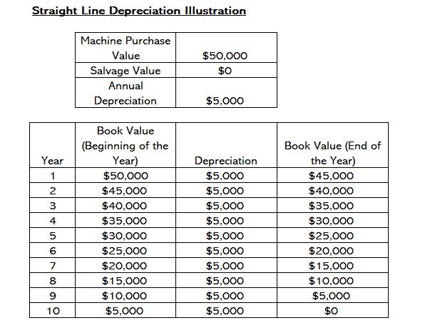

Depreciation – Double Declining Method
Compared to other depreciation methods, double-declining-balance depreciation results in a larger amount expensed in the earlier years as opposed to the later years of an asset’s useful life.
The method reflects the fact that assets are typically more productive in their early years than in their later years – also, the practical fact that any asset (think of buying a car) loses more of its value in the first few years of its use. With the double-declining-balance method, the depreciation factor is 2x that of the straight-line expense method.

Depreciation formula for the double-declining balance method:

Periodic Depreciation Expense = Beginning book value x Rate of depreciation

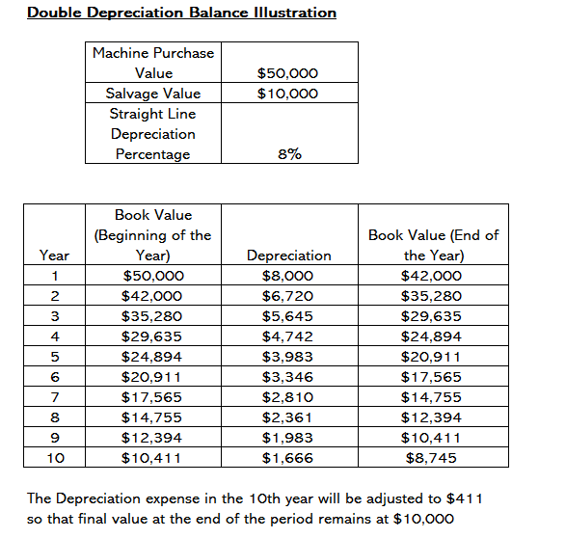

Depreciation – Units of Production Method

The units-of-production depreciation method depreciates assets based on the total number of hours used or the total number of units to be produced by using the asset, over its useful life.

The formula for the units-of-production method:

Depreciation Expense = (Number of units produced / Life in number of units) x (Cost – Salvage value)
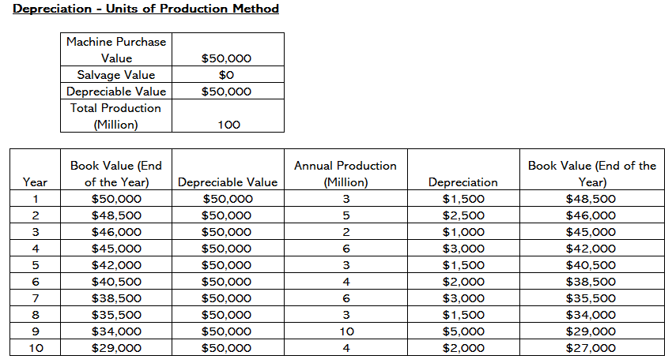

Depreciation – Sum of Years Method

he sum-of-the-years-digits method is one of the accelerated depreciation methods. A higher expense is incurred in the early years and a lower expense in the latter years of the asset’s useful life.

In the sum-of-the-years digits depreciation method, the remaining life of an asset is divided by the sum of the years and then multiplied by the depreciating base to determine the depreciation expense.

The depreciation formula for the sum-of-the-years-digits method:

Depreciation Expense = (Remaining life / Sum of the years digits) x (Cost – Salvage value)

The depreciation base is constant throughout the years and is calculated as follows:
Depreciation Base = Cost – Salvage value

Depreciation Base = $50,000 – $0 = $50,000

2. The remaining life is simply the remaining life of the asset. For example, at the beginning of the year, the asset has a remaining life of 10 years. The following year, the asset has a remaining life of 9 years, etc.

3. RL / SYD is “remaining life divided by sum of the years.” In this example, the asset has a useful life of 8 years. Therefore, the sum of the years would be 1 + 2 + 3 + 4 + 5 + 6 + 7 + 8+9+10 = 55 years. The remaining life in the beginning of year 1 is 10. Therefore, the RM / SYD = 10 / 55 = 0.1818.

4. The RL / SYD number is multiplied by the depreciating base to determine the expense for that year.

5. The same is done for the following years. In the beginning of year 2, RL / SYD would be 9 / 55 = 0.1636. 0.1636 x $50,000 = $8,182 expense for year 2.

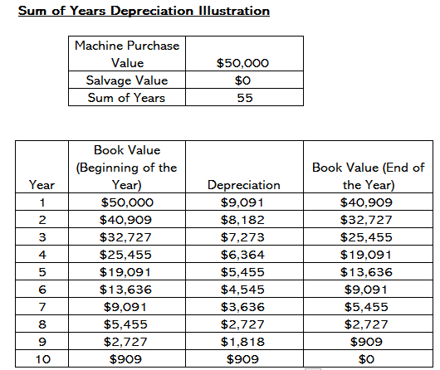

Long Term Assets – Intangible Assets
Intangible Assets
This line item includes all of the company’s intangible fixed assets, which may or may not be identifiable.
Identifiable intangible assets include patents, licenses, and secret formulas. Unidentifiable intangible assets include brand and goodwill.

Intangible assets cannot be touched. While intangible assets do not have a physical presence, they add value to your business. Intangible assets are long-term assets, meaning you will use them at your company for more than one year. Examples of intangible assets include goodwill, brand recognition, copyrights, patents, trademarks, trade names, and customer lists.

We can divide intangible assets into two categories: intellectual property and goodwill.

Intellectual property is something that we create with our mind, such as a design. You have rights to your intellectual property, and other companies cannot copy it. Intellectual property includes trademarks, patents, and licensing agreements.

Goodwill measures several factors that affect our brand’s value. Examples of goodwill include your company’s reputation, strategies, customer base, and employee relations.

Liabilities

Current Liabilities – Accounts Payable

Accounts Payable
Accounts Payables, or AP, is the amount a company owes suppliers for items or services purchased on credit. As the company pays off its AP, it decreases along with an equal amount decrease to the cash account.

Accounts payable (AP) is an accounting term used to describe the money owed to vendors or suppliers for goods or services purchased on credit. The sum of any and all outstanding payments owed by one organization to its suppliers is recorded as the balance of accounts payable on the company’s balance sheet, whereas the increase or decrease in total AP from the period prior will appear on the cash flow statement.
Accounts payable are usually due within 30 days and are recorded as a short-term liability on your company’s balance sheet. Only accrual basis accounting recognizes accounts payable (in contrast to cash basis accounting).

Current Liabilities – Current Debt

Current Debt/Notes Payable
Includes non-AP obligations that are due within one year’s time or within one operating cycle for the company (whichever is longest). Notes payable may also have a long-term version, which includes notes with a maturity of more than one year.

Current debt includes the formal borrowings of a company outside of accounts payable. This appears on the balance sheet as an obligation that must be paid off within a year’s time. Thus, current debt is classified as a current liability. This is not to be confused with the current portion of long-term debt, which is the portion of long-term debt due within a year’s time.

Current Liabilities – Current Portion of Long Term Debt
Current Portion of Long-Term Debt
This account may or may not be lumped together with the above account, Current Debt. While they may seem similar, the current portion of long-term debt is specifically the portion due within this year of a piece of debt that has a maturity of more than one year. For example, if a company takes on a bank loan to be paid off in 5-years, this account will include the portion of that loan due in the next year.

The current portion of long-term debt (CPLTD) is the amount of unpaid principal from long-term debt that has accrued in a company’s normal operating cycle (typically less than 12 months). It is considered a current liability because it has to be paid within that period.
Payment of CPTLD is mandatory according to the loan agreement the company signed with its lender.
Let's assume that a company has just borrowed $100,000 and signed a note requiring monthly payments of principal and interest for 48 months. Let's also assume that the loan repayment schedule shows that the monthly principal payments for the 12 months after the date of the balance sheet add up to $18,000. The current liability section of the balance sheet will report Current portion of long term debt of $18,000. The remaining amount of principal due at the balance sheet date will be reported as a noncurrent or long-term liability.

Long Term Liabilities – Bonds Payable
Bonds Payable
This account includes the amortized amount of any bonds the company has issued.
Bonds represent an obligation to repay a principal amount at a future date and pay interest, usually on a semi‐annual basis. Unlike notes payable, which normally represent an amount owed to one lender, a large number of bonds are normally issued at the same time to different lenders. These lenders, also known as investors, may sell their bonds to another investor prior to their maturity.
Types of bonds
There are many different types of bonds available to interested investors. Some of the more common forms are:
Serial bonds. Bonds issued in groups that mature at different dates. For example, $5,000,000 of serial bonds, $500,000 of which mature each year from 5–14 years after they are issued.
Sinking fund bonds. Bonds that require the issuer to set aside a pool of assets used only to repay the bonds at maturity. These bonds reduce the risk that the company will not have enough cash to repay the bonds at maturity.

Convertible bonds. Bonds that can be exchanged for a fixed number of shares of the company's common stock. In most cases, it is the investor's decision to convert the bonds to stock, although certain types of convertible bonds allow the issuing company to determine if and when bonds are converted.

Registered bonds. Bonds issued in the name of a specific owner. This is how most bonds are issued today. Having a registered bond allows the owner to automatically receive the interest payments when they are made.

Bearer bonds. Bonds that require the bondholder, also called the bearer, to go to a bank or broker with the bond or coupons attached to the bond to receive the interest and principal payments. They are called bearer or coupon bonds because the person presenting the bond or coupon receives the interest and principal payments.
Secured bonds. Bonds are secured when specific company assets are pledged to serve as collateral for the bondholders. If the company fails to make payments according to the bond terms, the owners of secured bonds may require the assets to be sold to generate cash for the payments.

Debenture bonds. These unsecured bonds require the bondholders to rely on the good name and financial stability of the issuing company for repayment of principal and interest amounts. These bonds are usually riskier than secured bonds. A subordinated debenture bond means the bond is repaid after other unsecured debt, as noted in the bond agreement.

Long Term Liabilities – Long Term Debt

Long-Term Debt
This account includes the total amount of long-term debt (excluding the current portion, if that account is present under current liabilities). This account is derived from the debt schedule, which outlines all of the company’s outstanding debt, the interest expense, and the principal repayment for every period.

Long-term liabilities, also called long-term debts, are debts a company owes third-party creditors that are payable beyond 12 months. This distinguishes them from current liabilities, which a company must pay within 12 months.

On the balance sheet, long-term liabilities appear along with current liabilities. Together, these represent everything a company owes. Payment of these debts is mandatory.

Because long-term liabilities are payable beyond 12 months—often for many years—companies tend to use them to finance assets that are also enduring in nature, such as land, buildings and equipment.

Working Capital
Working capital is calculated by subtracting current liabilities from current assets, as listed on the company’s balance sheet.
Positive working capital means the company can pay its bills and invest to spur business growth.
Working capital management focuses on ensuring the company can meet day-to-day operating expenses while using its financial resources in the most productive and efficient way.

Shareholder’s Equity

Shareholder’s Equity – Share capital

Share Capital
This is the value of funds that shareholders have invested in the company. When a company is first formed, shareholders will typically put in cash. For example, an investor starts a company and seeds it with $10M. Cash (an asset) rises by $10M, and Share Capital (an equity account) rises by $10M, balancing out the balance sheet.
Share capital (shareholders’ capital, equity capital, contributed capital, or paid-in capital) is the amount invested by a company’s shareholders for use in the business.

Share capital is sometimes broken out by firms into the different types of equity issued. There can be common stock and preferred stock, which are reported at their par value or face value.

Additional paid-in capital indicates the amount “paid-in” by investors and shareholders, and is the difference between the par value of a stock and the price that investors actually paid for it.

Common types of share capital
Authorized Share Capital
The total capital that a corporation accepts from its investors by issuing shares that are listed in the firm’s official documents is known as authorized share capital. Because a corporation is registered with this capital, it is also known as Registered Capital or Nominal Capital.

Issued Share Capital
The portion of Authorized Share Capital that is issued to the public for subscription is known as Issued Share Capital. Issuance, allocation, or allotment are the terms used to describe the act of issuing shares. To put it another way, Issued Share Capital is the subset of Authorized Share Capital. A subscriber becomes a shareholder after the allotment of shares.
Subscribed Capital
The portion of issued capital that has been sold to the public is known as subscribed capital. It is not necessary for the issued Capital to be fully subscribed by the general public. It is the portion of the issued capital for which the corporation has received an application.
Called-Up Capital
Called-up Capital is the portion of the Subscribed Capital that comprises the shareholder’s payment. The capital is not given to the company in its whole at once. It makes use of a portion of the subscribed capital when it is required in installments. Uncalled Capital refers to the remainder of the Subscribed Capital.
Paid-Up Capital

Paid-up Capital is the portion of Called-up Capital that is paid by the shareholder. The shareholder does not have to pay the sum requested by the corporation. The shareholder may pay half of the called-up Capital, referred to as Reserved Capital, to the company.

Shareholders Equity – Retained Earnings

Retained Earnings
This is the total amount of net income the company decides to keep. Every period, a company may pay out dividends from its net income. Any amount remaining (or exceeding) is added to (deducted from) retained earnings.
Retained earnings are the profits that a company has earned to date, less any dividends or other distributions paid to investors.
A growing company normally avoids dividend payments, so that it can use its retained earnings to fund additional growth of the business in such areas as working capital, capital expenditures, acquisitions, research and development, and marketing. It may also elect to use retained earnings to pay off debt, rather than to pay dividends. Another possibility is that retained earnings may be held in reserve in expectation of future losses, such as from the sale of a subsidiary or the expected outcome of a lawsuit.

Balance Sheet of Starhub

This is the statement of financial position (or balance sheet) of the Starhub group for period ending 31 Dec 2021.
We can see the different categories of current and long-term assets and liabilities and Equity.
The net assets is assets less liabilities and is the same as equity.
When the financial statements are presented to investors, accompanying notes are provided for all the main asset and liability entries to provide them more details of how these were arrived at.

Summary of different Balance Sheet Items

Summarise the different items and mention to learners that there will be a classroom activity on this soon.

Current Assets  Cash and cash equivalents  Accounts Receivable  Inventories  Marketable Securities  Long-Term Assets  Plant Property and Equipment (PP&E)  Intangible Assets | Current Liabilities  Accounts Payable  Current Debt / Notes Payable  Current Portion of Long Term Debt  Long-Term Liabilities  Bonds Payable  Long Term Debt  Shareholder’s Equity  Share Capital  Retained Earnings

Classification of items

Current Assets
Investment of $30,000 in fixed deposit – Current Asset as this is available at short notice (within 1 year)
Cash in savings account of $10,000 - Current Asset as this is available at short notice (within 1 year)
Unsold inventory of 100 computers valued at $150,000 - Current Asset as this is available immediately
Overdue amount of $5000 from customer - Current Asset as this can be available immediately as demanded by customer

Long Term Assets
Investment into a bond issued by Keppel Land maturing in 5 years – Long Term Assets as available in long term
Factory in Tuas valued at $2MM – Long Term Asset
Brand and Logo worth $100,000 – Intangible Long Term Asset

Current Liabilities
Amount of $2000 due to a supplier – Current liability as has to be paid to supplier within 1 year
Amount of $15,000 to be paid as loan instalment within the year - Current Liability as has to be paid to supplier within 1 year

Long Term Liabilities
Outstanding loan of $50,000 to bank with remaining tenor of 10 years – Long term liability as due after 1 year

Equity
Initial investment of $20,000 by company owners into the business
Accumulated and retained earnings of $23,000 in the company

Income Statement
This is also known as the profit and loss statement or the statement of revenue and expense
The income statement primarily focuses on the company’s revenues and expenses during a particular period and summarises the financial results.
The profit or loss is determined by taking all revenues and subtracting all expenses from both operating and non-operating activities.

Income Statement components

The income statement may have minor variations between different companies, as expenses and income will be dependent on the type of operations or business conducted. However, there are several generic line items that are commonly seen in any income statement.

The most common income statement items include:

Revenue/Sales
Sales Revenue is the company’s revenue from sales or services, displayed at the very top of the statement. This value will be the gross of the costs associated with creating the goods sold or in providing services. Some companies have multiple revenue streams that add to a total revenue line.

Cost of Goods Sold (COGS)
Cost of Goods Sold (COGS) is a line-item that aggregates the direct costs associated with selling products to generate revenue. This line item can also be called Cost of Sales if the company is a service business. Direct costs can include labor, parts, materials, and an allocation of other expenses such as depreciation

Gross Profit
Gross Profit Gross profit is calculated by subtracting Cost of Goods Sold (or Cost of Sales) from Sales Revenue.

Marketing, Advertising, and Promotion Expenses
Most businesses have some expenses related to selling goods and/or services. Marketing, advertising, and promotion expenses are often grouped together as they are similar expenses, all related to selling.

General and Administrative (G&A) Expenses
SG&A Expenses include the selling, general, and administrative section that contains all other indirect costs associated with running the business. This includes salaries and wages, rent and office expenses, insurance, travel expenses, and sometimes depreciation and amortization, along with other operational expenses. Entities may, however, elect to separate depreciation and amortization in their own section.

EBITDA
While not present in all income statements, EBITDA stands for Earnings before Interest, Tax, Depreciation, and Amortization. It is calculated by subtracting SG&A expenses (excluding amortization and depreciation) from gross profit.

Depreciation & Amortization Expense
Depreciation and amortization are non-cash expenses that are created by accountants to spread out the cost of capital assets such as Property, Plant, and Equipment (PP&E).

Operating Income (or EBIT)
Operating Income represents what’s earned from regular business operations. In other words, it’s the profit before any non-operating income, non-operating expenses, interest, or taxes are subtracted from revenues. EBIT is a term commonly used in finance and stands for Earnings Before Interest and Taxes.

Interest
Interest Expense. It is common for companies to split out interest expense and interest income as a separate line item in the income statement. This is done in order to reconcile the difference between EBIT and EBT. Interest expense is determined by the debt schedule.

Other Expenses
Businesses often have other expenses that are unique to their industry. Other expenses may include fulfillment, technology, research and development (R&D), stock-based compensation (SBC), impairment charges, gains/losses on the sale of investments, foreign exchange impacts, and many other expenses that are industry or company-specific.
EBT (Pre-Tax Income)
EBT stands for Earnings Before Tax, also known as pre-tax income, and is found by subtracting interest expense from Operating Income. This is the final subtotal before arriving at net income.

Income Taxes
Income Taxes refer to the relevant taxes charged on pre-tax income. The total tax expense can consist of both current taxes and future taxes.
Net Income
Net Income is calculated by deducting income taxes from pre-tax income. This is the amount that flows into retained earnings on the balance sheet, after deductions for any dividends.

Sample Income Statement
This shows as a sample layout of an income statement with some of the headings as discussed in earlier slide.
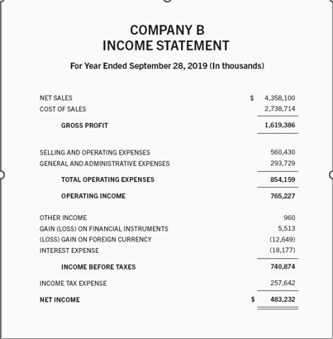

Earnings Per Share

Earnings per share (EPS) is a metric investors commonly use to value a stock or company because it indicates how profitable a company is on a per-share basis.

EPS is calculated by subtracting any preferred dividends from a company's net income and dividing that amount by the number of shares outstanding. Net income is the amount of money that remains in a reporting period after all cash and non-cash expenses are deducted, and net income minus preferred dividends is synonymous with a company's profit for the period. Preferred dividends must be subtracted because holders of preferred stock have contractual rights to dividend payouts.

For example in its most recent fiscal year, Netflix reported a net income of $2,761,395,000 and total shares outstanding of 440,922,000.

The company's balance sheet indicates Netflix has not issued any preferred stock, so we don't need to subtract out preferred dividends. Dividing $2,761,395,000 into 440,922,000 produces an EPS value of $6.26.

The main limitation of using EPS to value a stock or company is that EPS is calculated using net income. Non-cash expenses such as depreciation and amortization are subtracted from net income, and the lumpy nature of capital expenditures can cause a company's net income to vary greatly across reporting periods. Businesses can have much different non-operating expenses, such as tax and interest payments, which affect net income. A company's net income doesn't accurately reflect its cash flow or the health of its business.

Additionally, companies can and do manipulate their EPS numbers by changing the number of shares outstanding. Share issuances, splits, and stock buybacks all change the denominator by which net income less preferred dividends is divided.

EPS numbers are most useful when evaluated along with other metrics. The two most common are the price/earnings (P/E) ratio, which compares a company's stock price to its EPS, and the return on equity (ROE), which indicates how much profit a company generates from its net assets.

Diluted EPS numbers, unlike the "basic" method described above, account for all potential shares outstanding. Financial instruments like convertible debt and employee stock options, which are often used to raise capital and motivate employees, must be added to the outstanding share count to calculate a company's diluted EPS.

Netflix for example, granted 13,286,000 stock options to employees, which raises the total outstanding share count to 454,208,000. Dividing the same $2,761,395,000 of net income into 454,208,000 equals an EPS value of $6.08.

Accrual vs Cash Accounting

Companies can choose between two primary accounting methods: cash basis and accrual basis. The adage “timing is everything” captures the biggest difference between them. Cash accounting reflects business transactions on a company’s financial statements when the cash flows into or out of the business. Accrual accounting recognizes revenue when it’s earned and expenses when they’re incurred, regardless of when money actually changes hands. The difference in timing ripples through the company’s income statements and balance sheet, and subsequently affects its tax liability.

Cash-basis accounting is the easier of the two methods because, as its name implies, all bookkeeping simply follows the cash. The company records revenue when customer payments are received. It records expenses when it makes payments to suppliers. Taxes are calculated on the resulting net income.

Under the cash basis, there is no need to account for customer sales made on credit (i.e. accounts receivable) until they pay. Similarly, no bookkeeping is required for purchases from vendors on credit (i.e. accounts payable or accrued expenses) until the company pays for them. Cash-basis accounting is a simple way to easily see a company’s cash status.

Accrual-basis accounting combines two important accounting principles: the matching principle and the revenue recognition principle. Under these principles, revenue is recognized when it is earned, and expenses are reflected in the period that best matches the revenue they help create. Accrual accounting bookkeeping is uncoupled from when the money involved actually changes hands, thereby smoothing the impact of timing and yielding a more accurate overall picture of a business’ operations.

Businesses that use cash basis accounting recognise income and expenses only when money changes hands. They don’t count sent invoices as income, or bills as expenses – until they’ve been settled.

Businesses that use accrual accounting recognise income as soon as they raise an invoice for a customer. Similarly when a bill comes in, it’s recognised as an expense even if payment won’t be made for another 30 days.

Expense Recognition

Accrued Expenses – Example
For example, a company consumes $5,000 utility bill in February. The expense for the utility consumed remains unpaid on the balance day (February 28). The company then receives its bill for the utility consumption on March 05 and makes the payment on March 25.

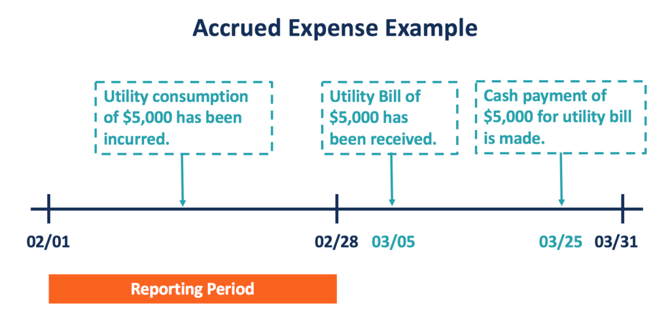
Under the accrual method of accounting, the entry for the transaction should be recorded in the reporting period of February, as shown below:


On the balance day, the accrued expense of utility is treated as a current liability (Utility Payable) owed to the utility company, and an expense (Utility Expense) incurred by the company in February.

In the reporting period of March, the company should record its cash payment on March 25 for its utility bill. This entry includes a counter account for the utility payable from the previous period and a cash account.



Revenue Recognition

Deciding when to record revenue and expenses can have a huge impact on the financial statements. Incorrectly recording revenue that has not been earned can inflate profits and give potential investors or lenders incorrect information about the company’s future profitability.

Revenue should be recorded when it is earned, essentially when the work is done.

According to the IFRS criteria, for revenue to be recognized, the following conditions must be satisfied:

- Risks and rewards of ownership have been transferred from the seller to the buyer.
- The seller loses control over the goods sold.
- The collection of payment from goods or services is reasonably assured.
- The amount of revenue can be reasonably measured.
- Costs of revenue can be reasonably measured.

Conditions (1) and (2) are referred to as Performance. Regarding performance, it occurs when the seller has done what is to be expected to be entitled to payment.

Condition (3) is referred to as Collectability. The seller must have a reasonable expectation that he or she will be paid for the performance.

Conditions (4) and (5) are referred to as Measurability. Due to the accounting guideline of the matching principle, the seller must be able to match the revenues to the expenses. Hence, both revenues and expenses should be able to be reasonably measured.

Cash Flow Statement

The cash flow statement shows the source of cash and helps you monitor incoming and outgoing money. Incoming cash for a business comes from operating activities, investing activities and financial activities. The statement also informs about cash outflows, expenses paid for business activities and investment at a given point in time. The information that you get from the cash flow statement is beneficial for the management to take informed decisions for regulating business operations.

Companies generally aim for a positive cash flow for their business operations without which the company may have to borrow money to keep the business going.

Cashflow statement – Operating Activities
Operating activities are those cash flow activities that either generate revenue or record the money spent on producing a product or service. Operational business activities include inventory transactions, interest payments, tax payments, wages to employees, and payments for rent. Any other form of cash flow, such as investments, debts, and dividends are not included in this section.

The operations section on the cash flow statement begins with recording net earnings, which are obtained from the net income field on the company’s income statement. This gives an estimate of the company’s profitability. After this, it lists non-cash items involving operational activities and convert them into cash items. A business’ cash flow statement should show adequate positive cash flow for its operational activities. If it doesn’t, the business may find it difficult to manage its daily business operations.

Cashflow statement – Investing Activities

This records the gains and losses caused due to investment in assets like property, plant, or equipment (PPE) thus reflecting overall change in the cash position for a company. When analysts want to know the company’s investment on PPE, they check for changes on a cash flow statement.

Capital expenditure (CapEx) is another important line item under investment activities. CapEx is the money which a business invests on fixed assets like buildings, vehicles or land. An increase in CapEx means the company is investing on future operations. However, it also shows that there is a decrease in company cash flow.

Sometimes a company may experience negative cash flow due to heavy investment expenditure, but this is not always an indicator of poor performance, because it may be leading to high capital growth.

Cashflow statement – Financing Activities
Records the cash flow between the company and its owners and creditors. Financial activities include transactions involving debt, equity, and dividends. In these transactions, incoming cash is recorded when capital is raised (such as from investors or banks), and outgoing cash is recorded when dividends are paid.

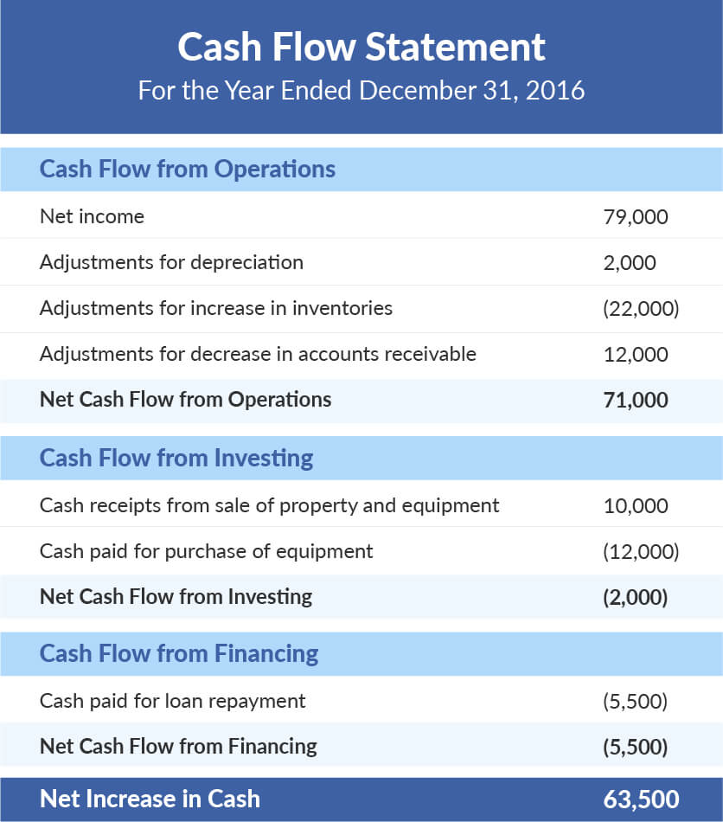

Statement of changes in equity

The statement of changes in equity is a reconciliation of the beginning and ending balances in a company’s equity during a reporting period. It is not considered an essential part of the monthly financial statements, and so is the most likely of all the financial statements not to be issued. However, it is a common part of the annual financial statements. The statement starts with the beginning equity balance, and then adds or subtracts such items as profits and dividend payments to arrive at the ending balance. The general calculation structure of the statement is as follows:

Beginning equity + Net income – Dividends +/- Other changes = Ending equity
Statement of changes in equity helps users of financial statement to identify the factors that cause a change in the owners’ equity over the accounting periods. Whereas movement in shareholder reserves can be observed from the balance sheet, statement of changes in equity discloses significant information about equity reserves that is not presented separately elsewhere in the financial statements which may be useful in understanding the nature of change in equity reserves.
Examples of such information include share capital issue and redemption during the period, the effects of changes in accounting policies and correction of prior period errors, gains and losses recognized outside income statement, dividends declared and bonus shares issued during the period.

Statement of changes in equity - components

Opening Balance
This represents the balance of shareholders’ equity reserves at the start of the comparative reporting period as reflected in the prior period’s statement of financial position. The opening balance is unadjusted in respect of the correction of prior period errors rectified in the current period and also the effect of changes in accounting policy implemented during the year as these are presented separately in the statement of changes in equity (see below).

Effect of Changes in Accounting Policies
Since changes in accounting policies are applied retrospectively, an adjustment is required in stockholders’ reserves at the start of the comparative reporting period to restate the opening equity to the amount that would be arrived if the new accounting policy had always been applied.

Effect of Correction of Prior Period Error
The effect of correction of prior period errors must be presented separately in the statement of changes in equity as an adjustment to opening reserves. The effect of the corrections may not be netted off against the opening balance of the equity reserves so that the amounts presented in current period statement might be easily reconciled and traced from prior period financial statements.
Restated Balance
This represents the equity attributable to stockholders at the start of the comparative period after the adjustments in respect of changes in accounting policies and correction of prior period errors as explained above.
Changes in Share Capital
Issue of further share capital during the period must be added in the statement of changes in equity whereas redemption of shares must be deducted therefrom. The effects of issue and redemption of shares must be presented separately for share capital reserve and share premium reserve.

Dividends
Dividend payments issued or announced during the period must be deducted from shareholder equity as they represent distribution of wealth attributable to stockholders.
Income / Loss for the period
This represents the profit or loss attributable to shareholders during the period as reported in the income statement.

Changes in Revaluation Reserve
Revaluation gains and losses recognized during the period must be presented in the statement of changes in equity to the extent that they are recognized outside the income statement. Revaluation gains recognized in income statement due to reversal of previous impairment losses however shall not be presented separately in the statement of changes in equity as they would already be incorporated in the profit or loss for the period.

Other Gains & Losses
Any other gains and losses not recognized in the income statement may be presented in the statement of changes in equity such as actuarial gains and losses

Closing Balance
This represents the balance of shareholders’ equity reserves at the end of the reporting period as reflected in the statement of financial position.

Summary of Income Statement Items
Summarise the formula for the different profit measures in income statement and let participants know that there will be activity on this later

Summary of Cashflow items
Summarise the formula for the different cash flow statement activities

Proforma Financial Statements (Projection)

Pro forma financial statements are based on certain assumptions and projections about the business. Pro forma statements allow us to compare actual financial events to your financial plan and make any necessary adjustments throughout the year.

Forecasting can be done for a business’s income statements and balance sheets. A cash flow forecast can then be derived from the data in the income statement and balance sheets.

Projection of Income Statement

The following steps are undertaken to prepare a proforma income statement

Analyze Historical Data
To accurately forecast your company’s profits or losses, you’ll first need to understand its past performance and use that data to predict future financial outcomes. Make sure you’re using comparable data. If you’re developing a pro forma income statement for a one-year period beginning January 1, 2020, you’ll want to look at historical data from the same period in previous years. Best practices suggest analyzing at least two periods worth of historical data, so you would want to look at income statements from January 1, 2018 and January 1, 2019.

Forecast Your Revenue
The easiest way to create a revenue (or sales) forecast is to input your annual growth rate. Look at the percentage growth in revenue over previous periods, and use that information to make an informed assumption about your future revenue.

Predict Cost of Goods Sold
As a service-based business, cost of goods sold might not seem to directly apply to your company. But service-based businesses should think of their costs related to labor, employment tax and benefits as their cost of goods sold. Sometimes, this is called the cost of services instead.

Determine Your Operating Expenses
Analyze your past operating expenses and compare them to your expected revenue to determine what your expected operating costs will be in your forecast. Operating expenses include office rent, business insurance, office supplies, salary and benefits for employees, and more.

Calculate projected Net Income
This is after taking into account all the above projected numbers

Forecasting of Balance Sheet

Forecasting your business’s balance sheet involves estimating your company’s assets and liabilities for a future date. A balance sheet is a financial document that gives a summary of your business’s financial position on a specific day. Balance sheet forecasts, or pro forma balance sheets, are used to project how your company will manage its assets in the future.

To create a pro forma balance sheet we perform the following steps:

Input Short-Term and Long-Term Assets
Begin by inputting short-term assets, which includes current cash assets and your accounts receivable. Then, input long-term assets, which would include things like: buildings, property and vehicles.

Include Current and Long-Term Liabilities
Account for current liabilities, which include all liabilities that business must settle in cash within the next year. We also include long-term liabilities, which are all liabilities due in more than one year. Liabilities include payroll, labor services and loan payments.

Calculate the Final Figures
To figure out final projections, just subtract liabilities from the assets. This final forecast of your balance sheet will give you important insights into how secure your business’s financial position will be at a future date and can help you decide if you need to consider cutbacks or apply for loans.

Forecasting of Cash Flow Statement

To forecast your business’s cash flow you’ll estimate the amount of cash flowing into and out of your company for a specific future period. A pro forma cash flow statement can help you identify where your business may experience cash shortfalls in future, so you can plan accordingly to offset lean times.

Here are the steps to forecasting your cash flow statement:

Estimate Your Anticipated Sales by Month
Use at least two years of historical sales data to calculate what sales you can anticipate by month. Make sure to look at seasonal data to see if there are patterns to your sales. You’ll also want to factor in any future plans, like if you know that a big new client will sign on to your business in the coming months.

Predict When You’ll Receive Payments
Estimate when you’ll receive future payments by relying on historical data. If you invoice clients using a 30-day billing cycle, you can predict when you’ll receive payments based on those due dates. If one of your clients frequently pays you after the due date, you’ll want to factor that into your projections.

Estimate Your Costs
Most small businesses have both fixed and variable costs. Account for your fixed costs, including rent and utilities. Your variable costs fluctuate based on how much work you’re producing. For a service-based business, variable costs could include printing, postage and travel costs related to business meetings.

Cash Flow forecasting methods

Direct
The direct method is less commonly used, but much easier to calculate. The direct cash flow forecasting formula is exactly what you would expect: cash flow = receivables - expenditures. As you can see, this method directly uses cash inflow and outflow to generate its output. The reason this method isn't very common is that it can become cumbersome to gather the data, especially for companies that use accrual-basis rather than cash-basis accounting.

Indirect
The indirect method for conducting cash flow forecasting starts with net income and then accounts for items that affect profit but not cash flow. In accrual-basis accounting, transactions are recorded before money actually changes hands. So accounts receivable and accounts payable must be adjusted to account for the actual flow of cash. Similarly, money that's been set aside for taxes, but not spent yet, needs to be added back in. Of course, you still must account for the money coming in from funding or paid back to sources of funding, as well as any assets purchased or sold.

Financial Ratios
Financial ratios are created with the use of numerical values taken from financial statements to gain meaningful information about a company. The numbers found on a company’s financial statements – balance sheet, income statement, and cash flow statement – are used to perform quantitative analysis and assess a company’s liquidity, leverage, growth, margins, profitability, rates of return, valuation, and more.

Analysis of financial ratios serves two main purposes:

1. Track company performance
Determining individual financial ratios per period and tracking the change in their values over time is done to spot trends that may be developing in a company. For example, an increasing debt-to-asset ratio may indicate that a company is overburdened with debt and may eventually be facing default risk.

2. Make comparative judgments regarding company performance
Comparing financial ratios with that of major competitors is done to identify whether a company is performing better or worse than the industry average. For example, comparing the return on assets between companies helps an analyst or investor to determine which company is making the most efficient use of its assets.

Liquidity Ratios
Liquidity ratios are financial ratios that measure a company’s ability to repay both short- and long-term obligations.

Liquidity Ratios – Current ratio
The current ratio measures a company’s ability to pay off short-term liabilities with current assets.
This ratio measures your company’s ability to meet short-term financial obligations by comparing your current assets against your current liabilities. Essentially, it’s a measure of your liquidity. Tracking the current ratio is important for understanding whether cash flow issues could comprise your ability to pay back liabilities. Conversely, if the ratio is high (indicating liquidity is good), it means you have more to invest in growth and can qualify for better financing agreements.

Liquidity Ratios – Acid Test Ratio
The acid-test ratio measures a company’s ability to pay off short-term liabilities with quick assets

Liquidity Ratios – Cash Ratio
The cash ratio measures a company’s ability to pay off short-term liabilities with cash and cash equivalents

Think of this as a more refined version of the current ratio. By subtracting inventory from current assets, you get a clearer picture of how many liquid assets are on hand, assets that can be quickly converted to cash. Comparing that figure against current liabilities provides a more accurate indication of whether your company can pay its debts. A low figure suggests cash flow issues could be forthcoming. Most companies raise the ratio by clearing out current liabilities, either by delaying purchases or taking out long-term loans.

Liquidity Ratios – Operating Cash Flow Ratio
The operating cash flow ratio is a measure of the number of times a company can pay off current liabilities with the cash generated in a given period

Leverage Financial Ratios

Leverage ratios measure the amount of capital that comes from debt. In other words, leverage financial ratios are used to evaluate a company’s debt levels.

Leverage Ratio – Debt Ratio
The debt ratio measures the relative amount of a company’s assets that are provided from debt

Leverage Ratio – Debt to Equity Ratio
The debt to equity ratio calculates the weight of total debt and financial liabilities against shareholders’ equity.

This ratio reveals how much your company is leveraged by comparing the amount of debt against the amount of equity ownership. In this case, equity is considered the amount the owners can put up for collateral after repaying the priority lenders. A higher ratio indicates the company could struggle to repay its debts, but actual performance is measured by comparing the ratio against industry benchmarks.

Leverage Ratio – Interest Coverage Ratio
The interest coverage ratio shows how easily a company can pay its interest expenses

Leverage Ratio – Debt Service Coverage Ratio
The debt service coverage ratio reveals how easily a company can pay its debt obligations

Efficiency Ratios
Efficiency ratios, also known as activity financial ratios, are used to measure how well a company is utilizing its assets and resources.

Efficiency Ratios – Asset Turnover Ratio
The asset turnover ratio measures a company’s ability to generate sales from assets

Efficiency Ratio – Inventory Turnover Ratio
The inventory turnover ratio is expressed as the number of times an enterprise sells out of its stock of goods within a given period of time. The ratio is calculated by taking the cost of goods sold over the average inventory for a particular time period (e.g., 1 year).

Efficiency Ratio – Accounts Receivable Turnover Ratio
The accounts receivable ratio evaluates the efficiency of revenue collection. It measures the number of times a company collects its average accounts receivable over a given period.

Average Collection Period
The average collection period is the length of time – on average – it takes a company to receive payments in the form of accounts receivable.
Calculating the average collection period for any company is important because it helps the company better understand how efficiently it’s collecting the money it needs to cover its expenditures.
The average collection period is calculated by dividing a company’s yearly accounts receivable balance by its yearly total net sales; this number is then multiplied by 365 to generate a number in days.

Importance of Average Collection Period
1. Maintain liquidity
Clearly, it is crucial for a company to receive payment for goods or services rendered in a timely manner. It enables the company to maintain a level of liquidity, which allows it to pay for immediate expenses and to get a general idea of when it may be capable of making larger purchases.

2. Plan for future costs and schedule potential expenditures
The average collection period figure is also important from a timing perspective to help a company prepare an effective plan for covering costs and scheduling potential expenditures to further growth.

For obvious reasons, the smaller the average collection period is, the better it is for the company. It means that a company’s clients take less time to pay their bills. Another way to look at it is that a lower average collection period means the company collects payment faster.

A fast collection period may not always be beneficial as it simply could mean that the company has strict payment rules in place. The rules may work for some clients. However, stricter collection requirements can end up turning some customers away, sending them to look for companies with the same goods or services and more lenient payment rules or better payment options.

Average Collection Period - Illustration
Let’s say that Company recorded a yearly accounts receivable balance of $40,000. In the same year, the company logged $400,000 in total net sales.

The first step to determining the company’s average collection period is to divide $40,000 by $400,000. The quotient, then, must be multiplied by 365 because the calculation is to determine the average collection period for the year.

It means that Company ABC’s average collection period for the year is about 36.5 days. It is slightly high when you consider that most companies try to collect payments within 30 days.
For the company, its average collection period figure can mean a few things. It may mean that the company isn’t as efficient as it needs to be when staying on top of collecting accounts receivable. However, the figure can also represent that the company offers more flexible payment terms when it comes to outstanding payments.

Efficiency Ratio – Accounts Payable Turnover Ratio
The accounts receivable ratio evaluates the efficiency of revenue collection. It measures the number of times a company collects its average accounts receivable over a given period.
Net Credit Purchases = Cost of Goods Sold (COGS) + Ending Inventory balance – Starting Inventory balance for a specified period. However, this is the formula for purchases in general. Net credit purchases are only the purchases made on credit. Alternatively, since the number for net credit purchases is difficult to find, analysts often substitute COGS as the numerator instead.
Average Accounts Payable is the sum of starting and ending accounts payable balances over a time period (e.g., monthly or quarterly), divided by 2. Both balances can be found on the company’s balance sheet.
The accounts payable turnover ratio represents the average number of times a company pays off its creditors during an accounting period. The ratio also serves as a measurement of short-term liquidity. A higher payable turnover ratio is favourable, as it enables the company to hold cash for a longer time. This, in turn, shrinks the working capital funding gap or working capital cycle.

Average Payments Period

Also known as an important solvency ratio, the average payment period (APP) assesses how much time it takes for a business to pay its vendors, in the case of purchases made on credit. Many times, when a business makes an important purchase, credit arrangements are made beforehand. These arrangements might give the buyer a specific amount of time to pay for the goods.

Defining the Average Payment Period
Frequently, when the payment is operated quickly, the buyer might take advantage of specific discounts, which would diminish the overall price of the purchase. For instance, in the case of a 10/30 credit term, as a buyer, you might benefit from a 10 percent discount, granted that the balance is paid within 30 days. In general, the standard credit term is 0/90 – which facilitates payment in 90 days, yet no discounts whatsoever.

The reason why this ratio is widely used is that it provides insight into a firm’s cash flow and creditworthiness. Basically, this means that, in some cases, it could highlight existing concerns. For instance, it might offer answers to question like: is the company capable of meeting its financial obligations or not? Can it use its cash flow in an efficient manner or not? Hence, analysts, investors, and creditors will definitely find this information vital.

Average Payments Period – Illustration

The company is running quite lean and is paying its creditors with an average payment of 180 days which is high and good.
This is good if they are not foregoing any discounts for early payments.

Profitability Ratios
Profitability ratios are a class of financial metrics that are used to assess a business's ability to generate earnings relative to its revenue, operating costs, balance sheet assets, or shareholders' equity over time, using data from a specific point in time.
These assess a company's ability to earn profits from its sales or operations, balance sheet assets, or shareholders' equity.
These indicate how efficiently a company generates profit and value for shareholders.
Higher ratio results are often more favourable, but these ratios provide much more information when compared to results of similar companies, the company's own historical performance, or the industry average.

Different profit margins are used to measure a company's profitability at various cost levels, including gross margin, operating margin, pretax margin, and net profit margin.
As more costs are added, the margins shrink as layers of additional costs are taken into consideration—such as the COGS, operating expenses, and taxes.

Profit Margins – Gross Margin

Gross margin measures how much a company makes after accounting for Cost of Goods Sold (COGS). The gross margin ratio compares the gross profit of a company to its net sales to show how much profit a company makes after paying its cost of goods sold.

Profit Margins – Operating Margin

Operating margin is the percentage of sales left after covering COGS and operating expenses. The operating margin ratio compares the operating income of a company to its net sales to determine operating efficiency

Profit Margins – Net Profit Margin

The net profit margin is a company's ability to generate earnings after all expenses and taxes.

Profit Margins – Return on Assets

Return on Assets
Profitability is assessed relative to costs and expenses and analyzed in comparison to assets to see how effective a company is deploying assets to generate sales and profits.
The use of the term "return" in the ROA measure customarily refers to net profit or net income—the value of earnings from sales after all costs, expenses, and taxes. ROA is net income divided by total assets.
The more assets a company has amassed, the more sales and potential profits the company may generate. As economies of scale help lower costs and improve margins, returns may grow at a faster rate than assets, ultimately increasing ROA.

Profit Margins – Return on Equity

Return on Equity (ROE)
ROE is a key ratio for shareholders as it measures a company's ability to earn a return on its equity investments.
ROE, calculated as net income divided by shareholders' equity, may increase without additional equity investments.
The ratio can rise due to higher net income being generated from a larger asset base funded with debt.
The total equity is the assets less liabilities or the total amount that would be available to shareholders once all the debts are paid off.

Illustrations of calculations of financial ratios

Financial Ratios in Banking

Bank-specific ratios, such as net interest margin (NIM), provision for credit losses (PCL), and efficiency ratio are unique to the banking industry. Similar to companies in other sectors, banks have specific ratios to measure profitability and efficiency that are designed to suit their unique business operations. Also, since financial strength is especially important for banks, there are also several ratios to measure solvency.

Ratios for Profitability
1. Net Interest Margin
Net interest margin measures the difference between interest income generated and interest expenses. Unlike most other companies, the bulk of a bank’s income and expenses is created by interest. Since the bank funds a majority of their operations through customer deposits, they pay out a large total amount in interest expense. The majority of a bank’s revenue is derived from collecting interest on loans.
The formula for net interest margin is:
Net Interest Margin = (Interest Income – Interest Expense) / Total Assets

Ratios for Efficiency
1. Efficiency Ratio
The efficiency ratio assesses the efficiency of a bank’s operation by dividing non-interest expenses by revenue.
The formula for the efficiency ratio is:
Efficiency Ratio = Non-Interest Expense / Revenue
The efficiency ratio does not include interest expenses, as the latter is naturally occurring when the deposits within a bank grow. However, non-interest expenses, such as marketing or operational expenses, can be controlled by the bank. A lower efficiency ratio shows that there is less non-interest expense per dollar of revenue.

2. Operating Leverage
Operating leverage is another measure of efficiency. It compares the growth of revenue with the growth of non-interest expenses.
The formula for calculating operating leverage is:
Operating Leverage = Growth Rate of Revenue – Growth Rate of Non-Interest expense
A positive ratio shows that revenue is growing faster than expenses. On the other hand, if the operating leverage ratio is negative, then the bank is accumulating expenses faster than revenue. That would suggest inefficiencies in operations.

Ratios for Financial Strength
1. Liquidity Coverage Ratio
As the name suggests, the liquidity coverage ratio measures the liquidity of a bank. Specifically, it measures the ability of a bank to meet short-term (within 30 days) obligations without having to access any outside cash.

The formula for the liquidity coverage ratio is:

Liquidity Coverage Ratio = High-Quality Liquid Asset Amount / Total Net Cash Flow Amount
The 30-day period was chosen as it is the estimated amount of time it takes for the government to step in and help a bank during a financial crisis. Thus, if a bank is capable of fund cash outflows for 30 days, it will not fall.

2. Leverage Ratio
The leverage ratio measures the ability of a bank to cover its exposures with tier 1 capital. As tier 1 capital is the core capital of a bank, it is also very liquid. Tier 1 capital can be readily converted to cash to cover exposures easily and ensure the solvency of the bank.
The formula for the leverage ratio is:
Leverage Ratio: Tier 1 Capital / Total Assets (Exposure)

3. CET1 Ratio
The CET1 ratio is similar to the leverage ratio. It measures the ability of a bank to cover its exposures. However, the CET1 ratio is a more stringent measurement, as it only considers the common equity tier 1 capital, which is less than the total tier 1 capital. Also, for the ratio’s calculation, the risk level of the exposure (asset) is considered as well. A higher risk asset is given a higher weighting of risk, which lowers the CET1 ratio.
The formula for the CET1 ratio is:
CET1 Ratio = Common Equity Tier 1 Capital / Risk-Weighted Assets

Lesson 2: Financial Performance Analysis and Capital Budgeting

Learning Objectives:
By the end of this session, learners will be able to
- Develop a holistic perspective on the organization working capital, financial structure, activity and profitability position using the balance sheet, statement of financial position and the statement of changes in equity
- compare, explain and project the historical trend of organization performance using the financial ratios
- perform financial analysis for capital budgeting

Financial Statements Analysis
Financial Statement Analysis is the evaluation of the company's financial situation in various entities by analyzing profits and losses, following up on administrative decisions, and contributing to the preparation of financial statements.

Financial statements include the income statement, cash flow statement, notes to accounts, balance sheet and the statement of changes in equity.

Financial statement analysis includes gaining an idea of a company's financial situation and providing assistance in making effective economic decisions.

Financial statement analysis is auditing and examining the financial statements of an entity, which contributes to determining the ability to implement its financial obligations and make better economic decisions to earn income in the future.

Financial Statements Analysis - methods

Horizontal analysis: Horizontal analysis is the comparison of the financial performance of the organization over two years or more.
The financial analyst compares the sales revenue with the financial amounts, which helps to calculate the percentages of changes between years for all financial balances, such as inventory balance and cash balance.

Vertical analysis: the vertical analysis is the calculation of each item in the financial statements as a percentage of the total.
The term vertical analysis is used because the annual figures are listed vertically in the financial statements.

The total of the income statement is the net income from sales, while the total of the balance sheet is the amount of assets in the enterprise.

Ratio analysis: Ratio analysis provides the financial analyst with the ability to compare the items of one financial statement or examine the relationships between all the items within two financial statements.
A relative valuation model is a method of determining the worth of an asset that takes into account the value of similar assets. It compares a firm's value with that of its competitors to assess the company's financial worth.
The implementation of the financial analysis to calculate the ratios of the financial statements every year helps analysts to study the trends of the entity over a set of years.
The use of this type of financial analysis facilitates the application of the comparison process between companies, and a set of terms and concepts are used in the relative analysis, including profitability ratios, financial suitability ratios, and liquidity ratios.

Ratio Analysis
We will use the ratios learnt in the previous lesson to evaluate the financial position of a company.

Ratio Analysis – Example
We will perform a financial analysis comparison between these two companies using ratio analysis
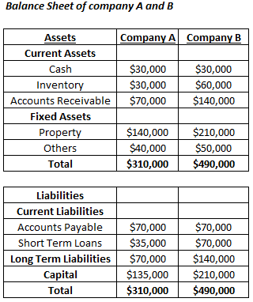

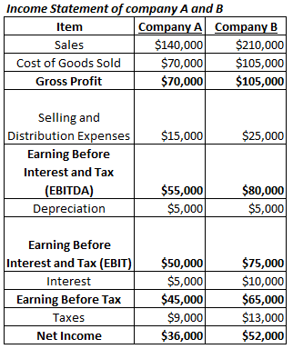

Current Ratio
Company B’s current ratio is better than that of Company A, which shows that Company B is better positioned to repay its current obligations.
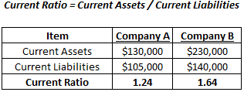

Quick Ratio
Company B’s quick ratio is better than that of Company A, which shows that Company B is better positioned to cover its current obligations instantly.

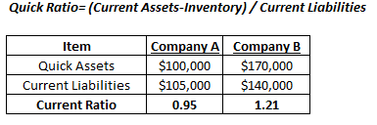

Operating Profitability
Measures the Operating efficiency of the company;
Both companies have similar operating profitability
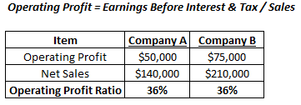

Overall Profitability
Company A has a better overall profitability than Company B.

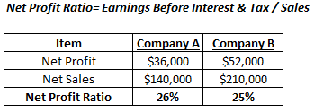

Return on Equity
Measures the overall return earned by the shareholders in the company.
Company A shareholders have received a better return than those of Company B
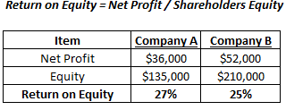

Return on Capital Employed
Capital employed in the business is the combination of long term debt and the shareholder capital.

Company A provides a better return to the providers of capital.

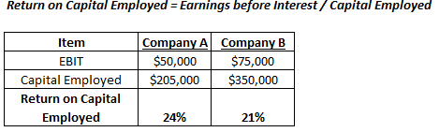

Inventory Turnover Ratio
These measures evaluating the effective level of managing the business’s inventory.
A higher ratio for company A means they are selling goods quickly and managing its inventory level effectively.

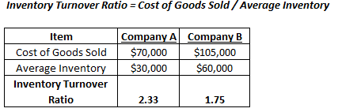

Receivables Turnover Ratio
Receivable Turnover Ratios help measure a company’s effectiveness in collecting its receivables or debts.
A higher ratio for company A means they are collecting their debt more quickly and managing their account receivables effectively.
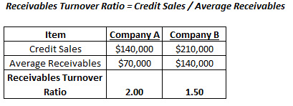

Payables Turnover Ratio
The payable Turnover Ratio helps quantify the rate at which a company can pay off its suppliers.
Higher ratio for company B means they are paying their bills more quickly and managing its payables more effectively. However conversely, it could also mean that they are not using supplier credit efficiently.

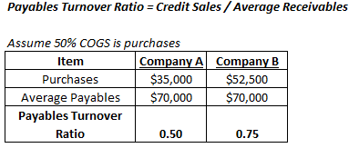

The Debt to Equity Ratio
This ratio measures the amount of equity available with the company to pay off its debt obligations.
Company B has a higher ratio and represents the company’s unwillingness to pay off its obligations. Therefore it is better to maintain the right debt-equity ratio to manage the company’s solvency.
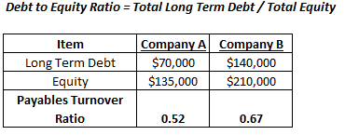

Financial Leverage
Financial leverage measures the number of assets available to equity holders of the company.
The slightly higher ratio of company B shows the higher the financial risk in terms of debt position to finance the company’s assets.
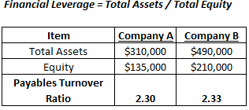

Horizontal Analysis
Horizontal analysis interprets the change in financial statements over two or more accounting periods based on the historical data. It denotes the percentage change in the same line item of the next accounting period compared to the value of the baseline accounting period.

Horizontal analysis is used for evaluating trends Year over Year (YoY) or Quarter over Quarter (QoQ). If you are an investor and thinking about investing in a company, only a year-end balance sheet or income statement would not be enough to judge how a company is doing. It would help if you looked at a couple of years to be sure. Better yet, you can see many years of balance sheets and income statements and make a comparison among them.

Through horizontal analysis of financial statements, you would be able to see two actual data for consecutive years and would be able to compare every item. And based on that, you can forecast the future and understand the trend.
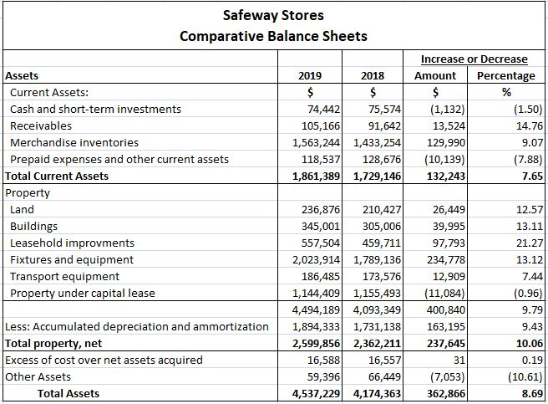

Vertical Analysis

Vertical analysis is a kind of financial statement analysis wherein each item in the financial statement is shown in the percentage of the base figure. It is one of the popular methods of financial statements used as it is simple and also called a common size analysis. Here, all the income statement items are stated as a percentage of gross sales. Likewise, all the items in the balance sheet are stated as a percentage of the total assets. Whereas the opposite of the vertical analysis of financial statements is the Horizontal analysis which always looks at the amount from the financial statement over the horizon of many years.

Horizontal Analysis – Case Study

We now look at performing horizontal analysis for a company.

First the ratios are generated. Then the year on year growth for items in balance sheet and income statement and the ratios are analysed.

For the calculation of the turnover ratios, we used the average of the inventory, receivables and payables for the current year and the previous year. Except the last year for which we will just us that year’s value.
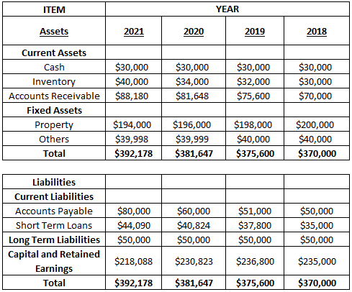

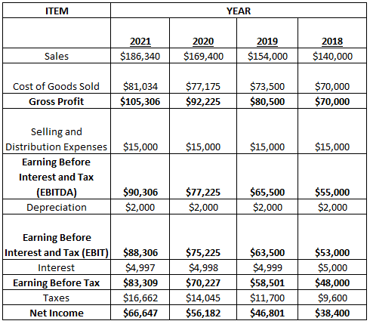

Step 1 – Generation of Ratios
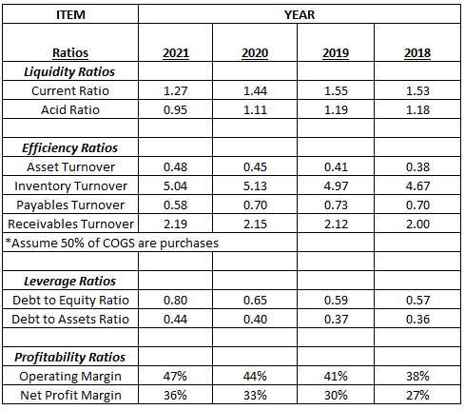

Step 2 – Trend Analysis of Balance Sheet

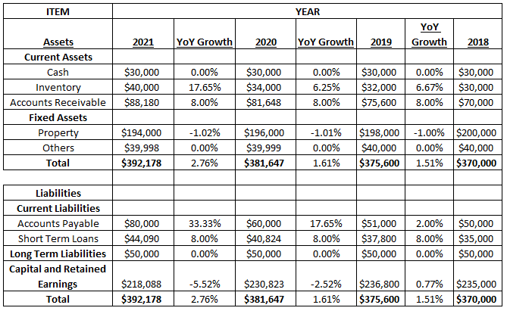
Step 3 – Trend Analysis of Income Statement

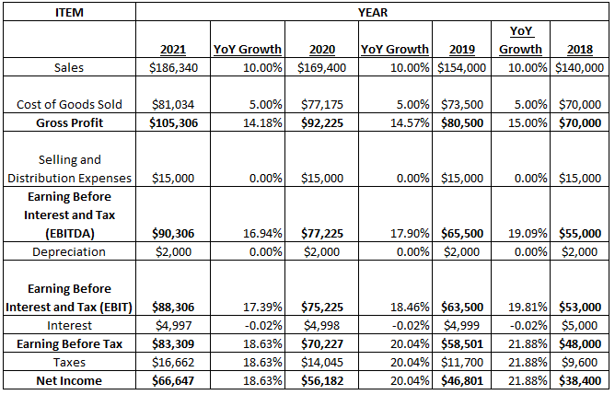

Step 4– Trend Analysis of Ratios
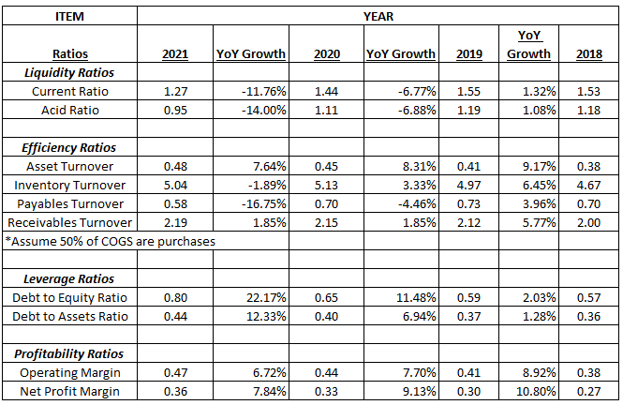

Benchmarking of Financial Performance

One of the most effective ways to compare two businesses is to perform a ratio analysis on each company’s financial statements. A ratio analysis looks at various numbers in the financial statements such as net profit or total expenses to arrive at a relationship between each number. To ensure accuracy, it is usually best if both statements have been audited by a certified public accountant, or CPA.

We should always compare apples to apples when evaluating two company’s financial results. It only makes sense to do a comparison of two companies in the same industry. Length of operation, business location, and types of products all play an important roll in a company’s financial results.

Comparing two company's financial results isn't the only measure of evaluating their profitability. For example, one business might be successful based on a key individual who may be leaving or retiring. In that case, the future results may not be as valid, because the prior results were based on the dependence of the key person.

We must ensure that both financial statements have been audited or at the very least prepared by a neutral, third-party accounting firm, to help ensure the integrity and accuracy of the reported numbers. Also, verify that the numbers reported are from the same accounting period such as January through December.

We can get trends of ratios across different companies in the industry and compare the company to see relative performance.

Capital Budgeting
Capital investments are long-term investments in which the assets involved have useful lives of multiple years. For example, constructing a new production facility and investing in machinery and equipment are capital investments. Capital budgeting is a method of estimating the ﬁnancial viability of a capital investment over the life of the investment.

Unlike some other types of investment analysis, capital budgeting focuses on cash ﬂows rather than proﬁts. Capital budgeting involves identifying the cash in ﬂows and cash out ﬂows rather than accounting revenues and expenses ﬂowing from the investment. For example, non-expense items like debt principal payments are included in capital budgeting because they are cash ﬂow transactions. Conversely, non-cash expenses like depreciation are not included in capital budgeting (except to the extent they impact tax calculations for “after tax” cash ﬂows) because they are not cash transactions. Instead, the cash ﬂow expenditures associated with the actual purchase and/or ﬁnancing of a capital asset are included in the analysis.

Over the long run, capital budgeting and conventional proﬁt-and-loss analysis will lend to similar net values. However, capital budgeting methods include adjustments for the time value of money.

Time value of Money
Time value of money (TVM) is the idea that money that is available at the present time is worth more than the same amount in the future, due to its potential earning capacity. This core principle of finance holds that provided money can earn interest, any amount of money is worth more the sooner it is received. One of the most fundamental concepts in finance is that money has a time value attached to it. In simpler terms, it would be safe to say that a dollar was worth more yesterday than today and a dollar today is worth more than a dollar tomorrow.

There are five (5) variables that you need to know:

Present value (PV) - This is your current starting amount. It is the money you have in your hand at the present time, your initial investment for your future.
Future value (FV) - This is your ending amount at a point in time in the future. It should be worth more than the present value, provided it is earning interest and growing over time.
The number of periods (N) - This is the timeline for your investment (or debts). It is usually measured in years, but it could be any scale of time such as quarterly, monthly, or even daily.
Interest rate (I) - This is the growth rate of your money over the lifetime of the investment. It is stated in a percentage value, such as 8% or .08.
Payment amount (PMT) - These are a series of equal, evenly-spaced cash flows.

Capital Budgeting Process
Below are the steps involved in capital budgeting.
Identify long-term goals of the individual or business.
Identify potential investment proposals for meeting the long-term goals identiﬁed in Step 1.
Estimate and analyze the relevant cash ﬂows of the investment proposal identiﬁed in Step 2.
Determine ﬁnancial feasibility of each of the investment proposals in Step 3 by using the capital budgeting methods outlined below.
Choose the projects to implement from among the investment proposals outlined in Step 4.
Implement the projects chosen in Step 5.
Monitor the projects implemented in Step 6 as to how they meet the capital budgeting projections and make adjustments where needed.

Capital Budgeting Methods
There are several capital budgeting analysis methods that can be used to determine the economic feasibility of a capital investment. They include the Payback Period, Discounted Payment Period, Net Present Value, Proﬁtability Index, Internal Rate of Return, and Modiﬁed Internal Rate of Return.

Payback Period
A simple method of capital budgeting is the Payback Period. It represents the amount of time required for the cash ﬂows generated by the investment to repay the cost of the original investment. For example, assume that an investment of $600 will generate annual cash ﬂows of $100 per year for 10 years. The number of years required to recoup the investment is six years.

The Payback Period analysis provides insight into the liquidity of the investment (length of time until the investment funds are recovered). However, the analysis does not include cash ﬂow payments beyond the payback period.
In the example above, the investment generates cash ﬂows for an additional four years beyond the six year payback period. The value of these four cash ﬂows is not included in the analysis. Suppose the investment generates cash ﬂow payments for 15 years rather than 10. The return from the investment is much greater because there are ﬁve more years of cash ﬂows. However, the analysis does not take this into account and the Payback Period is still six years.

Payback Period Example
Comparison of Payback period of three projects with an initial cash outflow of $1000 and given future cash inflows.
Three capital projects are outlined in the table.
Each requires an initial $1,000 investment. But each project varies in the size and number of cash ﬂows generated. Project C has the shortest Payback Period of two years. Project B has the next shortest Payback (almost three years) and Project A has the longest (four years). However, Project A generates the most return ($2,500) of the three projects. Project C, with the shortest Payback Period, generates the least return ($1,500). Thus, the Payback Period method is most useful for comparing projects with nearly equal lives.
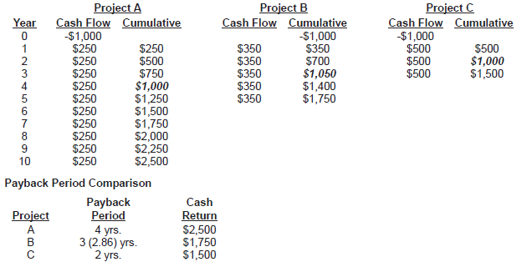

Discounted Payback Period

The Payback Period analysis does not take into account the time value of money. To correct for this deﬁciency, the Discounted Payback Period method was created. As shown in Figure 1, this method discounts the future cash ﬂows back to their present value so the investment and the stream of cash ﬂows can be compared at the same time period. Each of the cash ﬂows is discounted over the number of years from the time of the cash ﬂow payment to the time of the original investment. For example, the ﬁrst cash ﬂow is discounted over one year and the ﬁfth cash ﬂow is discounted over ﬁve years.

To properly discount a series of cash ﬂows, a discount rate must be established. The discount rate for a company may represent its cost of capital or the potential rate of return from an alternative investment.

Discounted Payback Period - Example

Discounted Payback Period analysis is shown using the same three projects as earlier, except the cash ﬂows are now discounted. You can see that it takes longer to repay the investment when the cash ﬂows are discounted. For example, it takes 3.54 years rather than 2.86 years (.68 of a year longer) to repay the investment in Project B. Discounting has an even larger impact for investments with a long stream of relatively small cash ﬂows like Project A. It takes an additional 1.37 years to repay Project A when the cash ﬂows are discounted. It should be noted that although Project A has the longest Discounted Payback Period, it also has the largest discounted total return of the three projects ($1,536).
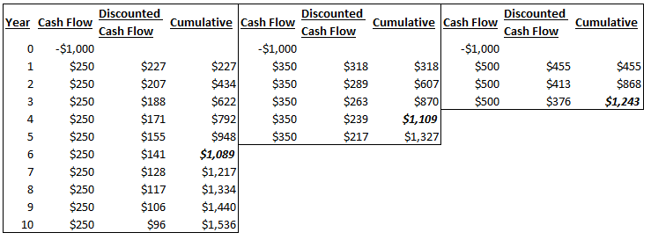

Net Present Value

The Net Present Value (NPV) method involves discounting a stream of future cash ﬂows back to present value. The cash ﬂows can be either positive (cash received) or negative (cash paid). The present value of the initial investment is its full face value because the investment is made at the beginning of the time period. The ending cash ﬂow includes any monetary sale value or remaining value of the capital asset at the end of the analysis period, if any. The cash inﬂows and outﬂows over the life of the investment are then discounted back to their present values.

The Net Present Value is the amount by which the present value of the cash inﬂows exceeds the present value of the cash outﬂows. Conversely, if the present value of the cash outﬂows exceeds the present value of the cash inﬂows, the Net Present Value is negative. From a different perspective, a positive (negative) Net Present Value means that the rate of return on the capital investment is greater (less) than the discount rate used in the analysis.

The discount rate is an integral part of the analysis. The discount rate can represent several different approaches for the company. For example, it may represent the cost of capital such as the cost of borrowing money to ﬁnance the capital expenditure or the cost of using the company’s internal funds. It may represent the rate of return needed to attract outside investment for the capital project. Or it may represent the rate of return the company can receive from an alternative investment. The discount rate may also reﬂect the Threshold Rate of Return (TRR) required by the company before it will move forward with a capital investment. The Threshold Rate of Return may represent an acceptable rate of return above the cost of capital to entice the company to make the investment. It may reﬂect the risk level of the capital investment. Or it may reﬂect other factors important to the company. Choosing the proper discount rate is important for an accurate Net Present Value analysis.

Net Present Value Example
Calculate the Present Value of all the cash flows using the discount rate and add together to get the NPV.

We can observe that project is not feasible at a required rate of 5% (negative NPV), but becomes feasible when the required rate is 3% (NPV turns positive)

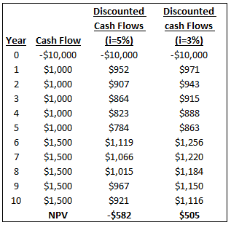

Profitability Index
Another measure to determine the acceptability of a capital investment is the Proﬁtability Index (PI). The Proﬁtability Index is computed by dividing the present value of cash inﬂows of the capital investment by the present value of cash outﬂows of the capital investment. If the Proﬁtability Index is greater than one, the capital investment is accepted. If it is less than one, the capital investment is rejected.

Profitability Index – Example
For these cash flows at a discount rate of 5%, the PI is less than 100% (or 1) and therefore not acceptable, At discount rate of 3%, PI is greater than 1, hence the project is acceptable.

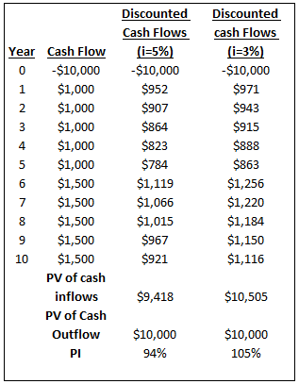

Internal Rate of Return
Another method of analyzing capital investments is the Internal Rate of Return (IRR). The Internal Rate of Return is the rate of return from the capital investment. In other words, the Internal Rate of Return is the discount rate that makes the Net Present Value equal to zero. As with the Net Present Value analysis, the Internal Rate of Return can be compared to a Threshold Rate of Return to determine if the investment should move forward.

Internal Rate of Return – Example
Project A has a higher IRR than Project B

Financial Ratios for a sample company
Gross Margin = Gross Profit / Sales = 45/120 = 37.50%
Operating Margin = Operating Profit / Sales = 32/120 = 26.67%
Net Profit Margin = Net Profit / Sales = 20/120 = 16.67%
Return on Equity = Net Income / Equity = 20/220 = 9.09%
Return on Assets = Net Income / Total Assets = 20/500 = 4%

